Catholic Schools Kenya
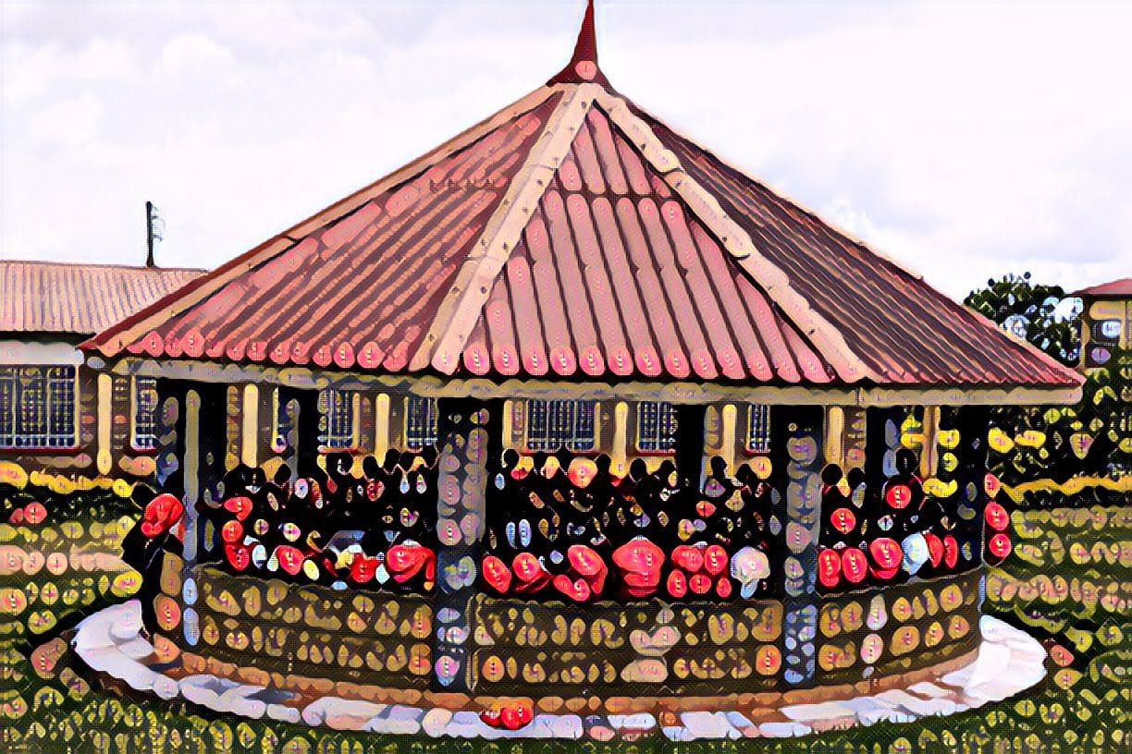
Donation Form

Date of Donation:

Last Name: First Name:
Street Address: City:
State: Zip Code: Country:
Email: Phone number:

Amount of donation:

Payment method: Check Zelle Venmo

Send form and payment to: Catholic Schools Kenya
82 Breakwater Street
Hampton VA 23669 USA

